SCILAB SOFTWARE
NOTE – All the programs are to be typed in SciNotes, saved, and then executed.
1. Ordinary Differential Equation – Runge Kutta 4th order Syntax - ode
function dt_dx=f(x, temp);
dt_dx=-40*x^3+72*x^2+24*x-70; //Given equation in the question
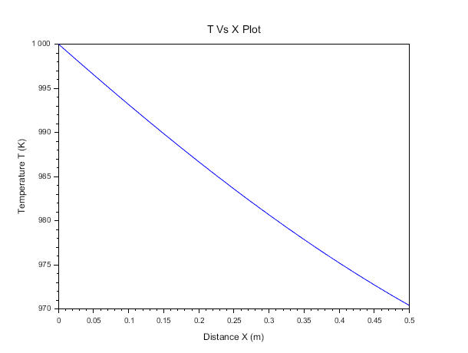
endfunction OUTPUT
temp0=1000;
x0=0;
x=0:0.025:0.5;
y=ode(temp0,x0,x,f);
plot(x,y);
xlabel("Distance X (m)");
ylabel("Temperature T (K)");
title("T Vs X Plot");
2. Non-linear equation – Newton Raphson method Syntax - fsolve
function value=mvol(v)
value=(p+a/(v*v))*(v-b)-r*t;
endfunction
// Values of p,t,tc, and pc are to be entered from data given in the question
p=30.5; //atm
t=273.15; //Kelvin
tc=304; //Kelvin
pc=72.9; //atm
r=0.0821; //atm.L/mol.K
a=27*r*r*tc*tc/(64*pc);
b=r*tc/(8*pc);
v0=r*t/p;
v=fsolve(v0,mvol); //Volume is in L/mol
disp(v)
OUTPUT
--> exec('C:\Users\Likhitha S Nayak\Documents\mvol.sci', -1)
0.5931865

3. Definite integral – Trapezoidal,Simpson’s 1/3rd rule Syntax - intg
function moles=f(x)
a=2.5; //Data
y=a*x/(1+(a-1)*x^0.98); //Equation from question
moles=1/(y-x);
endfunction
I=intg(0.03,0.2,f);
disp(I) //Integral value = ln(F/W)
F=500; //Data
W=F/exp(I); //ln(F/W)=I
disp(W) //No. of moles of residue left
OUTPUT
--> exec('C:\Users\Likhitha S Nayak\Documents\DI.sci', -1)
1.6025811
100.68803

4. Bubble pressure calculation Question 8(i)
function ps=bubblep(temp)
ps(1) = exp(14.5463 - 2940.46/(temp + 237.22)); //Data
ps(2) = exp(14.2724 - 2945.467/(temp + 224.00));
ps(3) = exp(14.2043 - 2972.64/(temp + 209.00));
endfunction
for i = 1:3
x(i) = input("Enter x value: ");
end
temp = input("Enter temperature: ");
ps = bubblep(temp);
Pbubble = sum(x .*ps);
mprintf("Bubble pressure = %f kPa\n", Pbubble);
for i=1:3
y(i)=x(i)*ps(i)/Pbubble;
mprintf("y(%d) = %f\n", i, y(i))
end
OUTPUT
--> exec('C:\Users\Likhitha S Nayak\Documents\bubblep.sci', -1)
Enter x value: 0.25

Enter x value: 0.35

Enter x value: 0.4

Enter temperature: 80

Bubble pressure = 103.309237 kPa
y(1) = 0.473697
y(2) = 0.331481
y(3) = 0.194822

5.Dew pressure calculation Question 9(i)
function ps=dewp(temp)
ps(1) = exp(14.5463 - 2940.46/(temp + 237.22)); //Data
ps(2) = exp(14.2724 - 2945.467/(temp + 224.00));
ps(3) = exp(14.2043 - 2972.64/(temp + 209.00));
endfunction
for i = 1:3
y(i) = input("Enter y value: ");
end
temp = input("Enter temperature: ");
ps = dewp(temp);
Pdew = 1 / sum(y ./ ps);
mprintf("Dew pressure = %f kPa\n", Pdew);
for i=1:3
x(i)=y(i)*Pdew/ps(i)
mprintf("x(%d) = %f\n", i, x(i))
end

OUTPUT
--> exec('C:\Users\Likhitha S Nayak\Documents\dewp.sci', -1)
Enter y value: 0.5

Enter y value: 0.3

Enter y value: 0.2

Enter temperature: 70

Dew pressure = 74.273923 kPa
x(1) = 0.256532
x(2) = 0.316631
x(3) = 0.426836

